SUPPLIER DETAILS
Name | Icefresh
MANUFACTURING SITE DETAILS (if different from above)
Site Approval Number | A485 |  | Lead Time
Name | Hólmadrangur ehf
Address | Kópnesbraut 2,  510 Hólmavík  Iceland
Technical Contact:- | Guðfinna Lára Hávarðardóttir
Mobile Number | 354 560 9260
Email | gudfinna@holm.is
Legislation Compliance Statement:- The Supplier must comply with all relevant UK and European Community Legislation and all relevant legal and food safety criteria.
The supplier is responsible for informing Seachill in writing and a minimum of one calendar month in advance of any proposed change of formulation, manufacturing process or packaging materials and changes in the origin places of process of any materials used to produce the product to be supplied to Seachill
The supplier is responsible for ensuring that all the relevant analytical, quality and food safety and process control records are held and maintained for a minimum of three years, unless otherwise required by law / agreement with Seachill. These records must be made available to representatives of Seachill upon request.
No change is to be made without the prior knowledge and prior written agreement of Seachill.
Seachill is a NUT FREE and GMO free site. Should there be any risk of cross contamination from such items during the production of this ingredient please inform your Technical contact at Seachill immediately.
SPECIFICATION APPROVAL
Approved for Seachill  Signature |  |  |  |  |  | Date
 |  | Name/Position
Approved on behalf of Supplier  Signature |  |  |  |  |  | Date
 |  | Name/Position

Product Details
COMMON NAME | Atlantic Prawns
SPECIES NAME | Pandalus Borealis
PRODUCT DESCRIPTION | MSC IQF Cooked and Peeled Cold Water Shrimp | Please or
Cooked | Raw |  | Cooked
Peeled | Shell on |  | Peeled
FRESH FROZEN | Fresh |  | Single Frozen
 |  |  | Double frozen
 | Shatterpack / Block |  | IQF
SIZE GRADE
- count /lb | Min | 100 | Target | 150 | Max | 200

Product Details contd.
Trim/ cutting /Portioning Requirements
Further Description | Cold chain (<3°C) maintained from catch to cooking.  Salt Content of 1.2-1.6%  Prawn maturation must be designed and controlled to ensure that salt uptake does not exceed 1.75% in the finished product (excluding glaze) and that texture is not adversely affected by prolonged brine immersion. The maturation period must be the minimum possible to allow effective peeling without loss of colour. Maturation must be performed in a temperature controlled environment. Where polyphosphates are used, the recipe must be less than 1% in the maturation brine solution. Polyphosphates must not be detectable in the finished product, above the level that occurs naturally in the prawn if tested without Polyphosphate being used in the brine. Polyphosphate must only be used at 1st stage maturation, raw, shell on.  Steam Cooking must achieve a microbiologically safe product with analytic evidence in place with the supplier.  The cooker has an alarm fitted to indicate any loss of temperature or steam pressure during production; the cooker belt stopping if the alarm operates.  Core temperature checks on cooked prawns performed at least once every hour and cover the width of the cooker belt, over the period of the production run. Prawns exiting the cooker probed to ensure they are achieving the equivalent thermal process for CCP compliance.  Temperature of product is reduced immediately after exiting cookers by the use of cold/chilled water reaching below 5°C within 10 minutes. Prawns are than peeled to remove all shell, legs and antennae. Then Quality checks are carried out. The prawns are then cleaned, first with water and then air, before passing through optic sorter & laser sorter and onto inspection belts for detailed hand inspection. Prawns are individually quick frozen to below -18°C. After freezing the prawns is given a protective water glaze by spray.
GLAZE LEVEL | Protective Glaze (declared 10±2% w/w is acceptable)
Max day ex catch/harvest  before freezing | Prawns frozen at sea on the vessel within 24 hours
TOTAL SHELF LIFE | 24 months
Minimum life remaining on delivery to Seachill | 75% of total life.
Storage Temperatures °C | Min <-18 °C | Max -18 °C
Temperature Range on delivery to Seachill °C | Min <-18 °C | Max -18 °C

INGREDIENT DECLARATION (include all components, sub ingredients and processing aids)
Ingredient | % Recipe | Supplier & Country Of Origin
MSC Cold Water Prawn (Pandalus Borealis) | 90.6% / 86.6% | EU- Canada
Water (glaze) | 10±2% | Strandabyggð, Iceland
Food Grade Salt | 1.4 | Akzonobel
Anti-caking agent in the salt | E535 | Akzonobel Netherlands
E451 (to aid shell removal) | 1% in the maturation mix (not detectable in finished product) | Katla Iceland

4. Catch/Harvest Information
WILD CAUGHT AREAS OF CATCH (FAO including Sub Areas) | FAO 21 and 27
FARMED FISH – Details for farms used and location | No
CATCH METHOD/HARVEST METHODS | Trawl
Do you have 3rd party certification of the supply chain(s) and or supplier assurance (e.g. MSC CoC ISO2200 or BRC, GFSI etc) Please list and provide certificate numbers if held | BRC and MSC
Sustainability/welfare/identity preserved information - MSC/Freedom Food /ASC/MCS/organic classification etc. Include license certificate number if held | MSC
Please detail any product integrity checks that you conduct on incoming raw materials | Temperature, texture, smell
Is the fish sourced from an MSC Fishery | N/A
Which exclusive economic zone (EEZ) /COO does the fish originate from? | N/A
Which body licenses vessels?
Are vessels on a Regional fisheries management organisation (RFMO) Approval list? | Yes
Only fish where the catch date, fishing method and FAO catch area are known should be used and details recorded on delivery paperwork for traceability.

Packaging
Tape on outer cases to be coloured.
Contact material | Heat sealed coloured polythene food grade liner
Material suitable for food contact | Yes
Outer packaging
Pallet type | Wood
Pack size (including protective glaze) | 2x5 kg

Labelling
Labelling to include the information below, please add a copy of an example label

Name of product including Size Grade
Species
Country of origin
Net / Gross Weight of glazed prawns.( or level of glaze)
The actual producing factory (either name or factory number).
Lot number
Imported by
Freezing date (DD/MM/YYYY)
Best before date (MM/YYYY)
Keep frozen below -18 °C
MSC CoC and MSC item on the product invoice required and on label

PHOTOGRAPHIC STANDARDS -TARGET
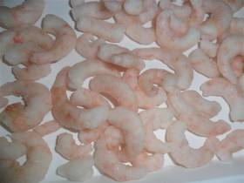 | 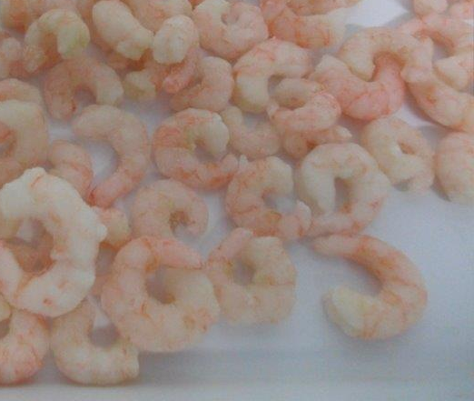

PHOTOGRAPHIC STANDARDS -REJECT
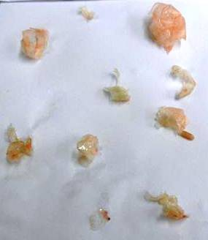

RAW MATERIAL QUALITY STANDARDS
Thawed
 | TARGET | REJECT
General appearance | Cooked, head and shell removed. Prawns shall show natural pink / red colouration with no translucence indicative of undercooking. There is no discoloration due to bruising or processing failures. Shell and defect levels within tolerances. | Presence of shell, legs etc above tolerance. Broken >5% by weight. Yellow or black discolouration. Other bi catch or foreign bodies
Aroma | Neutral, slight seafood. | Off ammoniacal odour/any chemical/sulphite odours. Any off smell.
Flavour / Taste | Clean, sweet, shellfish with a slight saltiness. | Bitter/sour/Off flavours.
Texture | Texture of defrosted prawns to be relatively firm but not tough or rubbery. Prawns to be meaty clean to the bite | Tough and chewy not clean to the bite or soft and mushy with not texture.

COLD WATER FROZEN PRAWN ASSESSMENT SCALE
Score |  |  | Target ≥7 |  |  | Reject < 7
CW Score / Rating | 5 Point Score / Rating | Colour |  | Odour | Flavour |  | Texture *
10 | 5 | Strong Pink / Red with well-defined markings |  | Sea-fresh typical of fresh Prawns | Sweet/Clean Flavour, Distinct Shellprawn, Pleasant salt flavour. |  | Firm with clean bite. Extra Succulent / Meaty / Tender
9 |  | Bright Pink / Red with well-defined markings |  | Sea-fresh or Neutral | Distinct Shellprawn / Sweetness |  | Very Succulent / Meaty / Tender
8 | 4 | Some loss of Pink colour but still with well-defined markings |  | Slight seaweedy odour / fresh prawn | Sweet/Clean Flavour some loss of flavour but still Distinct Shellprawn, Pleasant salt flavour. |  | Slight loss of Bite. Meaty / Tender / Soft
7 | 3 | Pale Pink to white (50:50)  Some yellow tips less than 3% affected |  | Neutral non obvious odour | Bland Little obvious shell prawn, not off. |  | Chewy texture but no toughness  Or Soft but still has a clean bite
6 | 2 | Predominantly White  Slight Yellow Ends Slight Translucent (Undercooked) |  | Slightly Musty/ammonia type odours.  Slight Stale not fresh | Slightly Prawny/musty flavour.  Noticeably Salty  Bitter aftertaste but not putrid.  Slight Cold store -  Caramel, Soapy  Slightly Raw,  Slight Taint |  | Very Soft and mushy little resistance to bite  Chewy and fibrous
5 Or Below | 1 | White Not Pink  White / Dehydrated Yellow or Discoloured Translucent (Raw) |  | Distinct-  Strong putrid  Prawny odours  Sour /Ammonia | Sour  Strong Salty  Strong, putrid prawny flavours  Stale Ammonia or sulphur flavours bitter after taste  Strong Cold store – Caramel, Soapy  Tainted Raw Prawn |  | Very soft mushy no resistance to bite  Slimy  Chewy, fibrous pieces remain in the month

Product Standard Key Outline Detail | Minimum | Target | Maximum
Average count /lb | 100 | As per on page 1 / specified by order | 350
Uniformity – | Weight of 10 largest pieces/weight of 10 smallest pieces the ratio should be no more than 2
Shell/Antenna |  | Absent | mm
Extraneous material (Extraneous material comprises natural prawn debris, such as antennae, eggs, eyes or pieces of shell greater than 5mm in diameter. Where a single prawn shows several defects, only one defect point should be attributed.) |  | Absent  If 4piece is found then a second sample of 454g must be checked for extraneous matter. If any extraneous matter is found in the second sample, then all prawns back to the last clear check must either be rejected, or re-inspected to bring them into specification. | >4 piece per 454g
Clumping - A clump is defined to be 2 or more prawns frozen together and not easily separated |  | Target: 0  Acceptable: 1 clump per 200g. | > 1 clump per 200g  4 prawn clumps are unacceptable
Broken (bits) (defined as pieces less than 10mm) |  | Target:<2% bw  Acceptable:<5% bw | >5% by weight
Discolouration (Yellowing, blackening) |  | Absent | 2 or more whole prawns with total yellowing per lb
Brown Discolouration (along gut line) |  | Absent | 5%
Salt |  | 1.4-1.6%
Added Glaze when purchased as 8% | 6% | 8% | >10%
Added Glaze when purchased as 10% | 8% | 10% | >12%
Added Glaze when purchased as 12% | 10% | 12% | >14%
Slow Frozen |  | Absent | Reject if Present
Gross misshapen |  | Absent | Reject if present
Freezing |  | Individually quick frozen to below -18°C
Dehydration (Where applicable) |  | Absent | Reject if present
Maturation brine solution |  |  | 1%
Foreign Material |  | Absent | Reject if present
Bycatch |  | Absent
Bycatch (Pandalus other Spp) | To be controlled at landing inspection of raw material with levels of less than 2%. All reasonable attempts to reduce it should be taken by the supplier.
Life remaining on receipt of delivery (Best Before date less date of delivery) |  | 12 months from actual production date | 12 months from actual production date
Under cooked prawns |  | Absent | Reject if present
Analytical Prawn Content | 88 | 90 | 100

MICROBIOLOGICAL STANDARDS (List Microbiological Testing Carried out)
Organism | Test Procedure Ref | Frequency | Target | Max.
TVC/ACC | NMKL Nr.86 5th Ed 2013 | daily | <10³ | 10⁴
Enterobacteriaceae |  |  | <100 | >1000
E. coli | ISO 9308-1:2014 | Every month | <1 | >10
Salmonella | PCT AOAC#031001 | Daily, analysed as an compound sample | Absent in 25g | Present in 25g
Vibrio species |  |  | NA | NA
Coliforms | ISO 4831:2006 | daily | 0 | 10
Listeria | PCR AOAC #21108 | Daily, analysed as an compound sample | Absent in25g | Present in 25g
Fecal coliforms | ISO 7251:2005 | daily | 0 | 1
Staphylococcus aureus | NMKL Nr.66 5th ed.2009 | Daily, analysed as an compound sample | <20 | >1000

CHEMICAL TESTING (List all relevant chemical testing carried out including Vet/Pesticide residues, Histamine, Heavy metal , Antibiotics, Salt etc.)
Test | Method | Frequency | Target | Max.
Heavy Metals
Antibiotic residues
Polyphosphates (i.e. Di and Tri breakdown) | Mg/g as P₂O₅ | We buy from a BRC supplier
Moisture
Aw
% Salt |  | We buy from a BRC supplier
Others
Is the lab accredited, provide lab name and accreditation body

NUTRITIONAL INFORMATION
 | UNITS | TYPICAL VALUES PER 100g | ANALYSIS OR CALCULATED (state Source)
Energy | kj | 418 | McCance & Widdowson
Energy | Kcal | 99 | McCance & Widdowson
Protein | g | 22.6 | McCance & Widdowson
Carbohydrate | g | 0 | McCance & Widdowson
of which sugars | g | 0 | McCance & Widdowson
of which starch | g | 0 | McCance & Widdowson
Fat | g | 0.9 | McCance & Widdowson
of which saturates | g | 0.2 | McCance & Widdowson
of which mono unsaturates | g | 0.2 | McCance & Widdowson
of which polyunsaturates | g | 0.2 | McCance & Widdowson
of which trans | g | 0 | McCance & Widdowson
Fibre | g | 0 | McCance & Widdowson
Sodium | mg | 1590 | McCance & Widdowson
Salt | g | 1.4 | Specification

FOREIGN BODY CONTROLS
Metal Detection
Is Metal Detection in Place for all material | yes
Test pieces used and sizes in mm Fe, Non Fe and S Steel | Fe | 2,0mm and 20mm | Non Fe | 2,5mm | SS | 4,0
Frequency at which the Metal detector is tested. | At the beginning of each packing round and hourly if the round is longer than 1 hour. Also tested at the end of the shift.
Filtration or Sieving
Are any components used in the process sieved or filtered (included water and brine solutions) | Yes filters on the water and the air into high risk.
If filtration or sieving in used what size specification is used. | EU7 600*600*640, EU 14 610*610*292, EU14 305*610*292
Wood Control
Do you have a policy to control wood and conduct regular audits? | Yes wood pallets are only allowed in certain areas of the factory
Glass Control/Hard Plastic
Do you have a policy to control glass/hard plastic and conduct regular audits? | Yes daily check
Bones/Shell Control
What controls are in place to reduce or eliminate bones or shell? | A stone catch, optical sorters and inspection belt. Samples are taken.
What frequency are checks conducted? | Each product code every hour.
Other Foreign Body Risks
If there are any specific foreign body controls associated with this raw material what controls are in place. (eg. Parasites) | stonecatcher used to prevent bigger things coming in with frozen prawns to get in to the factory.

Process flow diagram
Please provide a process flow description and diagram for this product, that includes all processes & process step controls from source (sea/farm) to dispatch:-
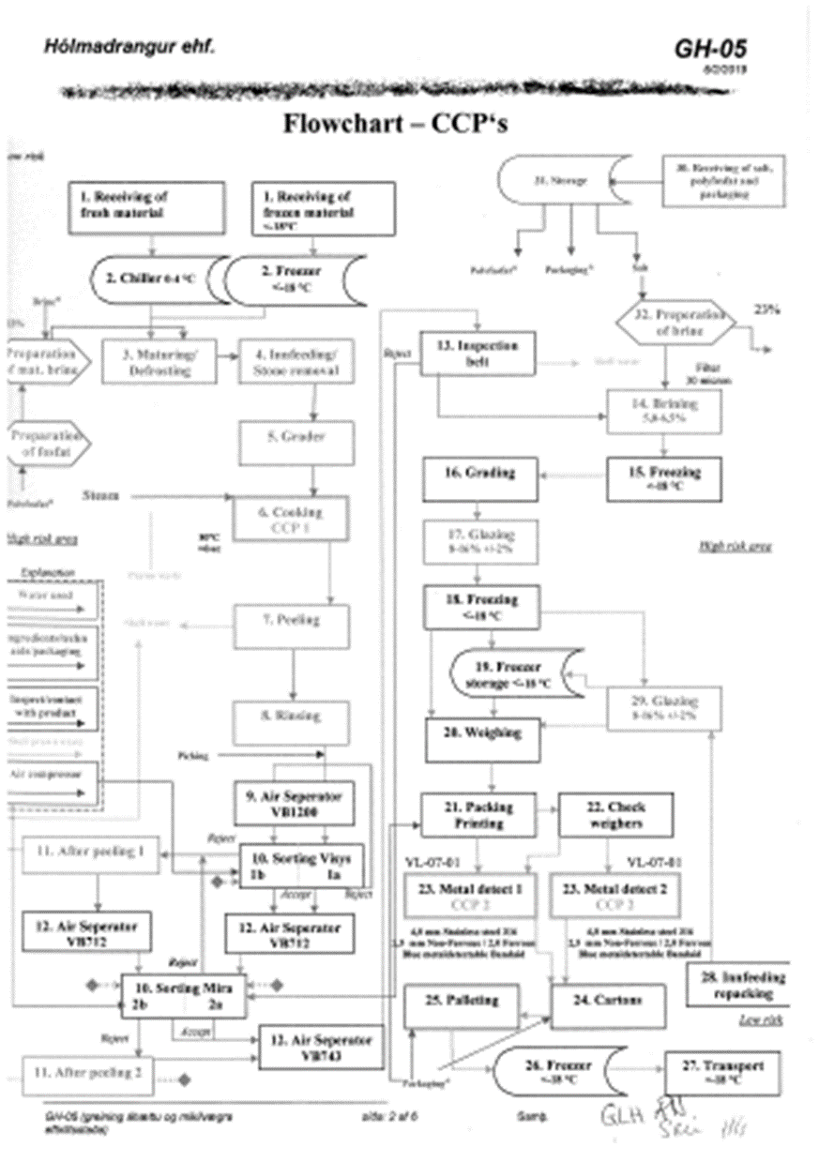

Logistical Supply Chain – tick all options that could apply through any part of the year.
Double click on any boxes you wish to tick and select “checked”.
Wild Capture Material sourced from:
We are vertically integrated, catch, process & transport our own products. Can trace prawn back to named vessels.
Purchased from market/auction in one country with material traceable back to named vessels.
Purchased from market/auction in many countries with material traceable back to named vessels.
Purchased from a previously approved list of named vessels.
Prawn are supplied by own named vessels.
Prawn are Supplied by Agent (give details):
Other supply route or 3rd parties (give details):
Material is transported to processing facility by:
By own secured transport
Approved haulier
Agents transport
N/A
Processing facility:
Product is not further processed
Processed in own facility
Processed by approved 3rd party
By agent
Storage:
Held in own processing facility awaiting despatch
Held in approved 3rd party secure storage
Despatched directly without storage
Transport to Seachill by:
Own secure transport
Approved 3rd party haulier
Under control of Seachill
Comments:

